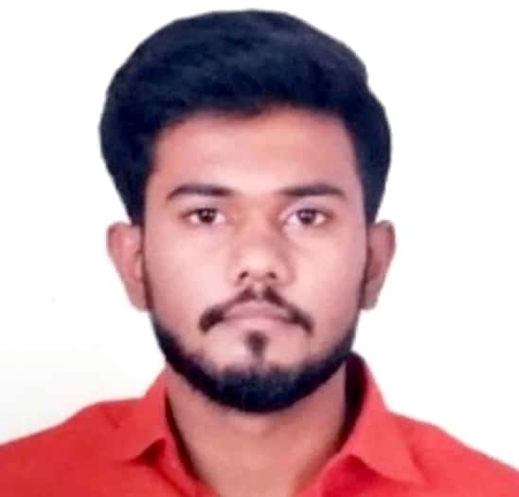**Abhijit Shirish Kharade**

Senapati chowk, senapati apt, Dapodi

Pune, Maharashtra-411012

🕿:+91-**8788262184** abhikharade3915@gmail.com

**Career Objective**

“To pursue a challenging career and be a part of progressive organization that gives a scope to enhance my knowledge and utilizing my skills towards the growth of the organization”.

**Education**

|  |  |  |  |  |
| --- | --- | --- | --- | --- |
| **Course** | **College/School** | **University/Board** | **Year** | **Percentage** |
| Bachelor Of Engineering | GSMCOE Balewadi, pune | PUNE | 2018 | 66.67% |
| Diploma in civil engineering | GSMCOE Balewadi, pune | MSBTE | 2015 | 70.56% |
| S.S.C | S.G.T.E.M.S Dapodi | Pune Board | 2012 | 72% |

**Areas of Interest:**

**Extra Curricular Activities:**

|  |  |  |  |
| --- | --- | --- | --- |
| **Title** | **Domain** | **Responsibility**  **& Contribution** | **Class** |
| T.B.M (Tunnel Boring Machine) | Transportation Engineering | Leadership,Collecting information about all aspects of project, Design the project | Diploma in civil engineering  (6th sem.) |
| Removal of Heavy Metals from Industrial Wastewater Using Low Cost Adsorbents | Environmental  Engineering | Collecting information about all aspects of project, Design the project | B.E CIVIL |

**Internship:**

**B.G.SHIRKE PVT LMT. MUNDHWA, PUNE (Jan 2018 to March 2018)**

Project: Road Project

**Hands-on Experience:**

***Calcraft Construction LLP,Bhosari (Sep 2018 to Jan 2019)***

Project: Industrial

**Designation: Junior Engineer**

***Saru Reality LLP. Hadapsar, (Feb 2019 to Sep 2019)***

Project:Residential

**Designation: Junior Engineer**

***Capacite Infra. Wakad (Sep 2019 to Sep 2020)***

Project: Commertial Mall

**Designation: Junior Engineer**

***MYK LATICRETE (Sep 2020 to March 2022)***

**QA/QC engineer for all projects in pune.**

***SAV chemicals pvt. Lmt (March 2022 to December 2022)***

Project: Industrial

**Designation: Project engineer**

**Activities**

* Computer course : AutoCAD
* Other activity : Badminton(Inter-school level)
* CESA President from 2016 to 2107
* Technical Head for 2018

**Hobbies:** Reading,Swimming, Travelling, market analysis, Farm work, Trekking

**Strengths**

* Ability to work hard and handle crisis situation & face challenges.
* Capable of working independently and in a team.
* Self- motivated.
* Ability to relate with people thought & effective communication skills.

**Personal Details:**

Name : Abhijit Shirish Kharade

Date of Birth : 26th AUG, 1996

Religon : **Hindu,Maratha**

Nationality : **Indian**

Marital Status : Un-married

**Health Status**

Height : 165cm

Weight : 60kg

Colour : Brown

Permanent Address : Senapati chowk, senapati apt, Dapodi

Pune, Maharashtra-411012

Languages Known : English, Hindi and Marathi

**Declaration:** I hereby declare that all the particulars mentioned above are true to the best of my knowledge and belief.

Date :

Place :

**Abhijit Shirish Kharade**